Enterprise: Everything eBooks and eAudiobooks in the catalog

While eBooks and eAudiobooks will appear alongside regular books when doing a search for “Everything”, the fastest way to find just eBooks or eAudiobooks is to search the “Digital Catalog”, which will return just eBooks and eAudibooks.

In the first dropdown box on the search bar, select “Digital Catalog”:

Enter in a search term and click “Search”. The Results:
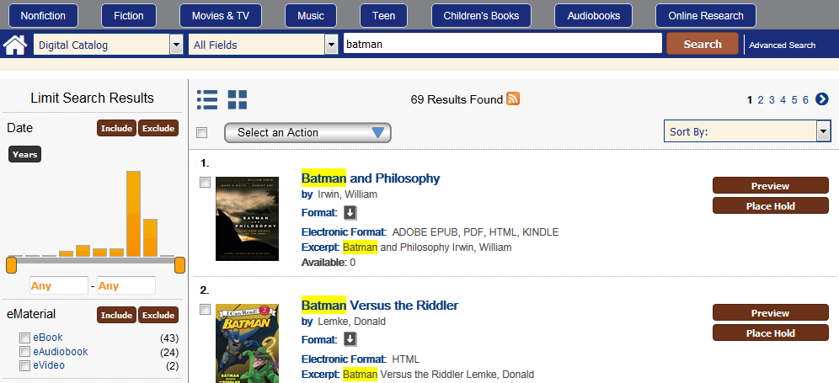

(Note that if you hover over the item’s format icon [in this case the book with the down arrow] it will show that this is an eBook.)
For items that are not available, you can place a hold on an item by clicking the brown “Place Hold” button.

Now, when I check my Account, I can open up the “Hold” tab, and look at “Digital Holds”:
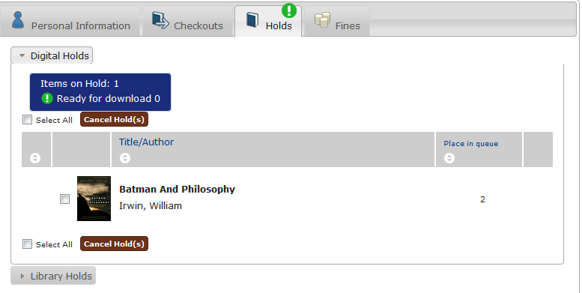
Holds can be canceled by clicking the checkbox to the left of the title and clicking the brown “Cancel Hold(s)” button.

To check out an item that is available:
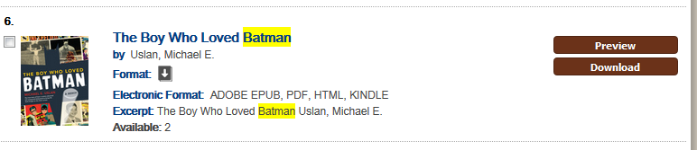

Click the “Download” button.
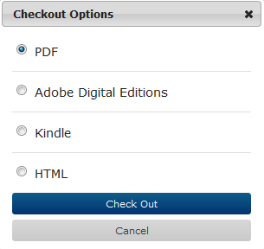

IF YOU DO NOT WANT TO DOWNLOAD THE ITEM RIGHT AWAY, CHOOSE HTML FORMAT.
Instead of downloading the item, choosing HTML format will have a new tab in the browser open with the eBook.

The same procedure applies with an eAudiobook: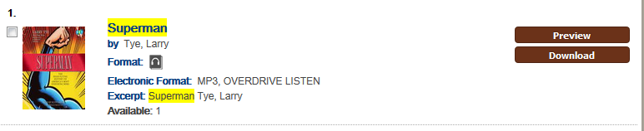

After clicking “Download”, select “OverDrive Listen” and click “Check Out”.
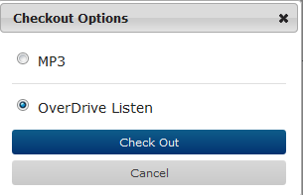
This will have the item opening in a new tab in the browser, configured as an audioplayer; it does not start playing until you click the “Play” button.

Opening eBooks and eAudiobooks in this method does not count towards the downloads that limit the ability to return a title before its expiration date.

To view your eBook and eAudiobook checkouts in My Account, open “Digital Checkouts” under the “Checkouts” tab:
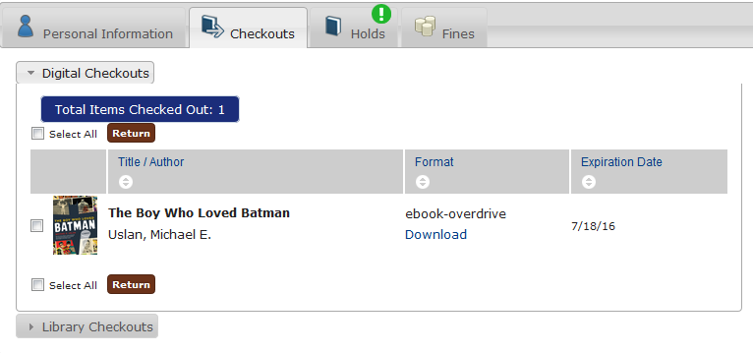
You can download the item again by clicking on the “Download” link in the “Format” column. By default, the item will download in the format chosen at the time of the initial checkout. You can always change the format for download by logging into the full Overdrive website (available on your library’s page for Downloadable Books.)

IF AN ITEM HAS NOT BEEN DOWNLOADED, there will be an option to check the box to the right of the item, and use the brown “Return” button to return the book, removing it from your account.

If an item has been downloaded, often you cannot return the item through Enterprise, though you may be able to return the item through the software or app used to download the item (see Overdrive’s support article for details, located here).

If you cannot return them through My Account in Enterprise, there will be a link (“Why can’t I return some titles?”) above the table of checkouts:
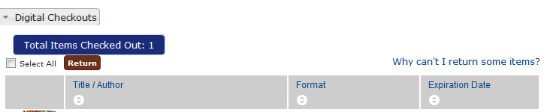

Clicking on this link will open a hover box with explanations why a title might not be able to be returned:
